Grade 7 Accelerated · Unit 3 · Lesson 8  Writing Large Numbers in Scientific Notation  Independent Set 3.08 ANSWER KEY | Name  Date  Period

Six questions, on your own, in silence. Show the step that does the work.
1. Write 8,200,000 in scientific notation.
8.2 × 10⁶

2. Write 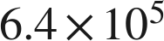 in standard form.
640,000

3. Write 915,000,000 in scientific notation.
9.15 × 10⁸
Three nonzero digits stay in the coefficient.

4. Which is greater,  or 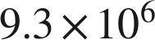 ?

The exponent decides first.

5. How many times larger is  than 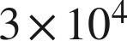 ?
3,000
9 ÷ 3 = 3, and 10⁷ ÷ 10⁴ = 10³.

6. A computer displays a number as 7.4E8. Write it in standard form.
740,000,000
E means times ten to the.

